John Maher

Chapter 4

Pg 231

SELECT * INTO sec0611_departments_copy FROM sec0611_departments;

| **sec0611_departments_copy** | | | |
| --- | --- | --- | --- |
| **DEPT_CODE** | **DEPARTMENT_NAME** | **MANAGER_NAME** | **ANNUAL_BUDGET** |
| Act | Accounting |  |  |
| Exe | Executive |  |  |
| Mkt | Marketing |  |  |
| Per | Personnel |  |  |
| Sal | Sales |  |  |
| Shp | Shipping |  |  |

Pg 232

SELECT * INTO sec0612_employees_copy FROM sec0612_employees;

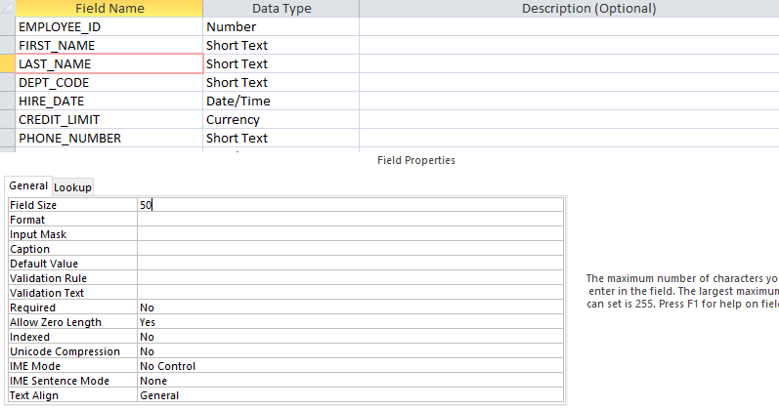

Pg 240

SELECT * FROM sec0616_duplicate_rows

| **Query1** | |
| --- | --- |
| **Num_col** | **Word_col** |
| 1 | One |
| 1 | One |
| 1 | One |
| 2 | Two |
| 2 | Two |
| 2 | Two |
| 2 | Two |
| 3 | Three |
| 3 | Three |

SELECT DISTINCT *INTO sec0616_no_duplicate_rows from sec0616_duplicate_rows;

| **Query1** | |
| --- | --- |
| **Num_col** | **Word_col** |
| 1 | One |
| 2 | Two |
| 3 | Three |

Pg 242

SELECT * INTO sec0617_duplicate_rows_with_number FROM sec0617_duplicate_rows;

ALTER TABLE sec0617_duplicate_rows_with_number ADD COLUMN row_id counter;

SELECT * FROM sec0617_duplicate_rows_with_number;

| **Query3** | | |
| --- | --- | --- |
| **Num_col** | **Word_col** | **row_id** |
| 1 | One | 1 |
| 1 | One | 2 |
| 1 | One | 3 |
| 2 | Two | 4 |
| 2 | Two | 5 |
| 2 | Two | 6 |
| 2 | Two | 7 |
| 3 | Three | 8 |
| 3 | Three | 9 |